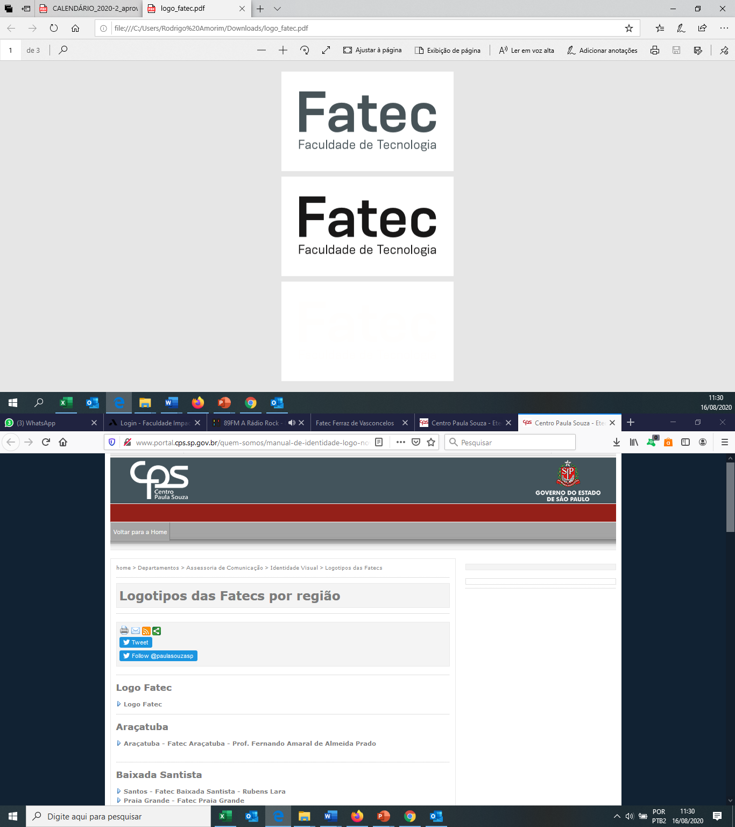

**Laboratório de Hardware**

**Prof. Rodrigo Amorim**

**Leonardo Reis de Brito**

**Montando um computador**

Elabore uma lista de componentes necessários para montar um computador pesquisando preços. Pesquise sobre 3 modelos diferentes de processador.

Ex:

|  |  |
| --- | --- |
| **Componente** | **Preço (R$)** |
| Placa-mãe Asrock A320m-hd Amd Am4 Matx Ddr4 | 600,00 |
| Processador gamer AMD Ryzen 5 3400G YD3400C5FHBOX de 4 núcleos e 3.7GHz de frequência com gráfica integrada | 1240,00 |
| Memória RAM 8GB 1x8GB Kingston HX426C16FB3/8 HyperX Fury | 350,00 |
| Fonte Gamer 500w Gamemax 80 Plus Bronze Gm500 | 500,00 |
| Gabinete |  |
| HD ou SSD |  |
| **Total** | **2690,00** |
|  |  |

|  |  |
| --- | --- |
| **Componente** | **Preço (R$)** |
| Processador AMD Ryzen 9 5950X, 16-Core, 32-Threads, 3.4GHz (4.9GHz Turbo), Cache 72MB, AM4, 100-100000059WOF | R$ 5.568,25 |
| Water Cooler NZXT Kraken Z73 360mm Display LCD, RL-KRZ73-01 | R$ 2.840,80 |
| Placa Mae Gigabyte B550 Aorus Master DDR4 Socket AM4 Chipset AMD B550 | R$ 3.863,52 |
| Memória Adata XPG Gammix D10 32GB (4x 16GB) DDR4 3600Mhz Preto, AX4U360016G18A-DB10 | R$ 4 283,84 |
| Placa de Video Gigabyte GeForce RTX 3080 Ti Aorus Master 12GB GDDR6X 384-bit, GV-N308TAORUS M-12GD | R$ 16.817,97 |
| SSD Corsair MP400, 8TB, M.2 2280, PCIe NVMe, Leitura 3480 MB/s, Gravacao 3000 MB/s, CSSD-F8000GBMP400 | R$ 12.500,29 |
| Gabinete Gamer Pichau Carrier II Lateral Vidro Temp RGB Rosa, PG-CR02-PKRGB | R$ 374,89 |
| Fonte Corsair AX850 Series 850W 80 Plus Titanium Modular, CP-9020151 | R$ 2.271,66 |
| **Total:** | **R$67.698,66** |

|  |  |
| --- | --- |
| **Componente** | **Preço (R$)** |
| Processador Intel Core i9-11900K, 8-Core, 16-Threads, 3.5GHz (5.3GHz Turbo), Cache 16MB, LGA1200, BX8070811900K | R$ 4.543,07 |
| Water Cooler NZXT Kraken Z73 360mm Display LCD, RL-KRZ73-01 | R$ 2.840,80 |
| Placa Mae MSI MEG Z590 Godlike DDR4 Socket LGA1200 Chipset Intel Z590 | R$ 10.227,14 |
| Memoria Adata XPG Spectrix D41 16GB (2x8) DDR4 3000MHz Cinza RGB, AX4U30008G16A-DT41 | R$ 907,98 |
| Placa de Video Gigabyte GeForce RTX 3080 Ti Aorus Master 12GB GDDR6X 384-bit, GV-N308TAORUS M-12GD | R$ 16.817,97 |
| SSD Corsair MP400, 8TB, M.2 2280, PCIe NVMe, Leitura 3480 MB/s, Gravacao 3000 MB/s, CSSD-F8000GBMP400 | R$ 12.500,29 |
| Gabinete Gamer Pichau Carrier II Lateral Vidro Temp RGB Rosa, PG-CR02-PKRGB | R$ 374,89 |
| Fonte Corsair AX850 Series 850W 80 Plus Titanium Modular, CP-9020151 | R$ 2.271,66 |
| **Total:** | **R$ 44.425,74** |

|  |  |
| --- | --- |
| **Componente** | **Preço (R$)** |
| Processador Intel Pentium Gold G6400, 2-Core, 4-Threads, 4GHz, Cache 4MB, LGA1200, BX80701G6400-TRAY | R$ 624,89 |
| Cooler Para Processador Thermaltake UX100 RGB, CL-P064-AL12SW-A | R$ 124,89 |
| Placa Mae Asus Prime H510M-E DDR4 LGA1200 Intel H510, PRIME H510M-E | R$ 746,48 |
| Memoria Corsair Vengeance LPX 4GB (1x4) DDR4 2400MHz C16 Preta, CMK4GX4M1A2400C16 | R$ 260,24 |
| Placa de Video Afox Radeon R5 220 2GB DDR3 64-bit, AFR5220-2048D3L5-V2 | R$ 249,89 |
| HD Seagate Barracuda 1TB 3.5" Sata III 6GB/s, ST1000DM010 | R$ 306,70 |
| Gabinete Gamer Pichau Carrier II Lateral Vidro Temp RGB Rosa, PG-CR02-PKRGB | R$ 374,89 |
| Fonte Duex DX 500W 80 Plus Bronze, DX 500FSE | R$ 295,34 |
| **Total:** | **R$ 2.625,32** |